

***Student Name - Kumar Gaurav***

***Student ID - 22026384***

***Course - MADSC303 Business Analytics***

***Professor Name - Ahmed S.Wafi***

***Final-Term***

*Table of Contents*

Introduction

3

**Part 1. Consumer analytics for Walmart**

4-8

**Part 2. Market analytics for Walmart**

**.........................................................................................................................................8**-14

**Part 3. Employee analytics for Walmart.**

....15-21

**Part 4. Business analytics's upcoming trends:**

21-30

Conclusion ........*............................................................................................................*......................31

References

32-33

# Introduction



"Walmart," One of the American biggest retail conglomerates in the world, Walmart is recognized for its broad product selection and global reach. Sam Walton founded Walmart in 1962, and since then it has expanded from a single cheap store in Rogers, Arkansas, to a global retail behemoth with hundreds of outlets With a purpose to "save people money so they can live better," Walmart has transformed the retail sector with its dedication to offering customers low-cost items and services. Sam's Club, Walmart Neighborhood Market, and Walmart Super Center are just a few of the brands that the business operates under to serve a variety of customer needs and preferences.

Data analytics has developed into a potent tool for firms to get useful insights and make wise decisions in today's fiercely competitive business environment. One of the biggest retailers in the world, Walmart, is aware of the role analytics plays in boosting staff productivity, market competitiveness, and consumer pleasure. Walmart can extract significant patterns, trends, and correlations from its enormous data sets by leveraging customer, market, and staff analytics. These analytics methods give the business the capacity to comprehend consumer behavior, improve pricing tactics, and raise engagement and productivity levels among staff members. We will highlight the value of employee analytics, market analytics, and customer analytics for Walmart and how they all contribute to the overall success of the business.

**Consumer analytics for Walmart**

1. **Customer analytics are crucial for comprehending consumer behavior, tastes, and wants.**

* Customer analytics is a critical tool for analyzing consumer behavior, interests, and demands as a manager of business analytics at Walmart.

1. Gaining deeper insights into consumer behavior patterns, purchase histories, and preferences is made possible through customer analytics. We may gain a thorough picture of our clients by looking at data about them, including transaction histories, demographics, and internet activities.
2. Marketing campaigns that are specifically suited to each customer's needs and a customized customer experience are made possible by customer analytics.
3. Customer analytics is crucial to the development and innovation of new products. We can discover new trends, preferences, and unfulfilled needs by examining customer feedback, reviews, and sentiment analysis.
4. Inventory Control and Demand Forecasting: Accurate demand forecasting is made possible through customer analytics. by examining previous sales information, seasonality, and consumer behavior.
5. With the help of customer analytics, we can predict customer retention and churn by identifying clients who may leave for a rival. We may proactively adopt retention strategies by investigating numerous client KPIs and engagement trends.

Note: In conclusion, Walmart requires customer analytics since it gives a thorough understanding of consumer behavior, preferences, and demands. Walmart can improve product development, customer service, marketing initiatives, and corporate growth by utilizing this expertise.

1. **The advantages and difficulties of putting customer analytics ideas into practice in a commercial setting.**

* As a manager of business analytics at Walmart, I can attest that putting customer analytics concepts into practice in a professional setting has both benefits and drawbacks. The following are some significant benefits and potential challenges:
* Advantages:

1. Decision-Making Based on Data: Customer analytics enables decision-making based on data. You may make wise choices about marketing tactics, product selection, and enhancements to the customer experience by studying consumer data. This produces corporate plans that are more focused and successful.
2. Personalized Customer Experiences: Customer analytics assist Walmart in providing customers with tailored experiences. You may adapt marketing campaigns, discounts.
3. Increased Operational Efficiency: By using customer data, you may improve operations. You may minimize stockouts, enhance supply chain management, and boost overall operational effectiveness by precisely estimating consumer demand and effectively controlling inventory levels.

* Difficulties:

1. Data Integrity and Quality: Integrating data from diverse sources while maintaining data integrity can be difficult. Data may be dispersed across several systems, inconsistent, or incomplete. Strong data governance procedures, data cleansing techniques, and efficient integration strategies are needed to overcome these obstacles.
2. Privacy and data security: It's essential for customer analytics to maintain customer privacy and data security. Customer data must be handled with care, and adequate security measures must be put in place to secure sensitive data, in order to comply with data protection laws like GDPR or CCPA.
3. Data Analysis and the Skills Gap: Skilled data analysts and data scientists are needed to extract valuable insights from customer data. Employing and retaining employees with the analytical expertise and domain knowledge needed to properly analyze and understand consumer data can be difficult for organizations.
4. **The Examine the impact of customer analytics on customer retention, loyalty, and satisfaction.**

* Certainly! As a manager of business analytics at Walmart, I can use customer analytics to promote customer pleasure, loyalty, and retention by focusing on the following important areas:

1. Understanding Customer Preferences: Through the analysis of customer data, Walmart is able to gather insights into the preferences and demands of its customers, enabling the development of customized solutions and business strategies.
2. Customer analytics makes it possible to focus promotions, tailor offers, and make pertinent recommendations, boosting the customer experience and promoting loyalty.
3. Proactive customer service: Examining customer encounters reveals areas that require improvement, allowing for quick response to client demands and issues.
4. Retention tactics: By identifying at-risk clients using customer analytics, tailored retention tactics can be put in place.
5. Continuous Improvement: Analytics-driven insights evaluate the success of programs, allowing for data-driven alterations for improved client interactions.
6. Engaging with consumers based on their input promotes satisfaction, loyalty, and a sense of worth.

Note: In conclusion, by utilizing customer analytics, Walmart is better able to comprehend its customers, tailor interactions, cater to their requirements, and constantly improve, all of which result in higher customer happiness, loyalty, and retention.

**Market analytics for Walmart**

1. **Walmart's use of market data, particularly in pricing strategies.**

* In order to create efficient pricing plans, as a manager's job would entail assessing market data, consumer behavior, and the competition landscape.

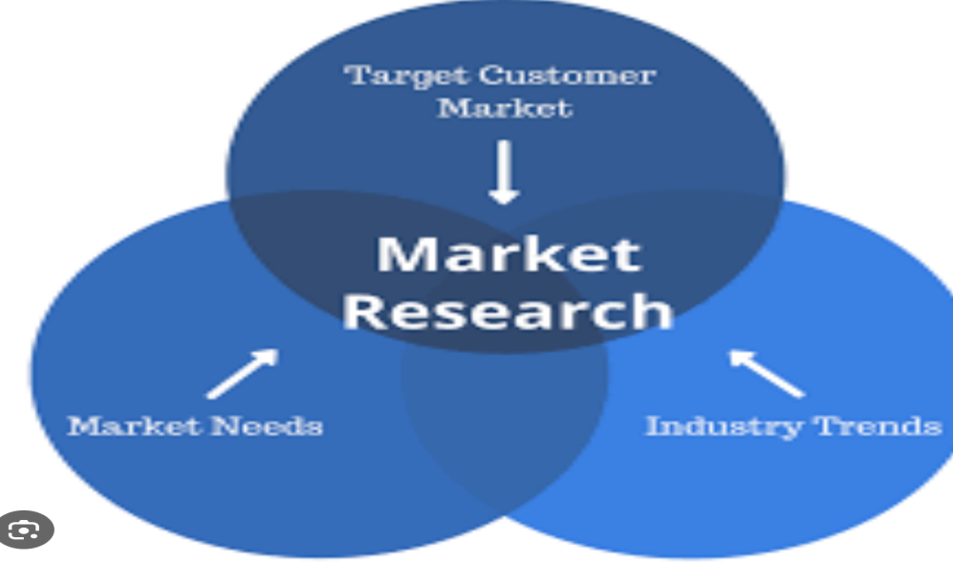

1. Conduct thorough market research to understand industry dynamics, customer trends, and rival companies' pricing tactics. To learn more about consumer preferences, price sensitivity, and market demand, consult a variety of data sources, including as market reports, customer surveys, and sales statistics.
2. Develop price strategies that are in line with Walmart's corporate objectives, target market segments, and competitive positioning. Think about elements including market conditions, price elasticity, competitive pricing, and product value.
3. Competitive Analysis: Track and evaluate the price, marketing, and positioning tactics of rival companies. Determine market opportunities and gaps, and suggest modifying price tactics as necessary.
4. Cross-functional Collaboration: To make sure pricing plans are in line with overarching business goals, work closely with cross-functional teams from merchandising, marketing, finance, and operations.
5. Testing and pricing optimization: Continually hone pricing approaches through trial and testing. To determine the best pricing structure, promotional offers, and markdown tactics, run A/B tests, price elasticity analysis, and other procedures.
6. Reporting and Presentation: To senior management and important stakeholders, prepare and deliver analytical results, insights, and recommendations. Create dashboards and reports to monitor price data, revenue trends, and profitability.
7. **A variety of pricing techniques, including dynamic pricing, cost-based pricing, and value-based pricing, and how well they work in various market conditions.**

* I will be in charge of analyzing various pricing strategies and determining their efficacy in various market conditions as a Business Analytics Manager at Walmart. Let's examine three prevalent pricing methods.
* value Price Based on Costs:

1. Cost-based pricing entails determining prices in accordance with the expenses paid in the manufacture, distribution, and sale of a good or service. In order to establish the ultimate price, this tactic often involves adding a markup or profit margin to the costs.
2. Commodity Items: Cost-based pricing can assist secure profitability and preserve competitiveness when products are comparatively standardized and price-sensitive.
3. Cost-based pricing can offer consistency and predictability in pricing decisions if the costs involved in manufacturing and selling a product are generally steady over time.

* Price based on value

1. Value-based pricing entails determining costs in accordance with the customer's estimation of the worth of a good or service. The goal of this method is to take home a reasonable portion of the value that customers enjoy.
2. Differentiated Products: Value-based pricing assists in capturing the premium that buyers are ready to pay when a product delivers distinctive features, greater quality, or creative solutions.
3. Value-based pricing enables price differentiation depending on various client categories, taking into account each group's willingness to pay and sense of value.

* Adaptive Pricing:

1. Dynamic pricing entails modifying prices in real-time in response to changes in the market, demand, and other pertinent variables. Retailers can use this method to adjust pricing for the most possible revenue or profit.
2. Demand Variability: Dynamic pricing can help modify prices to match demand levels and maximize income when demand for a good or service changes dramatically over time or as a result of outside influences.
3. Pricing from competitors: With dynamic pricing, it is possible to respond quickly to changes in rival pricing, enabling price leadership or retaining competitiveness in a market that is rapidly evolving.
4. **The effect of pricing tactics on demand, profitability, and consumer perception.**

* As a Manager I would be a key player in determining how pricing tactics affect customer perception, demand, and profitability as a Business Analytics Manager at Walmart. Here are some important things to think about:
* Customers' viewpoints : Pricing tactics can have a big impact on how customers view a product or brand. Different pricing strategies might send clients different messages. For instance:

1. Value Perception: Lower pricing can imply affordability and value, luring clients who are sensitive to price.
2. Prices that are greater may be perceived as being of higher quality or as being more exclusive, appealing to clients looking for high-end products.
3. Assessing how price tactics effect customer perception and brand positioning can be done by analyzing customer feedback, surveys, and market research.

* Demand : Pricing policies have a direct impact on consumer demand for goods and services. Important factors include:

1. Price Sensitivity: Knowing how consumers react to price fluctuations aids in establishing the ideal level of pricing. Elasticity analysis can show how demand changes in response to price changes.
2. Competitive Dynamics: It's critical to keep an eye on competition pricing and market conditions in order to modify prices in order to stay competitive and efficiently meet client demand.
3. Assessing how price tactics affect customer demand can be done by looking at sales data, doing market research, and using statistical models.

* Profitability is a key factor in what drives pricing choices. Important things to think about include:

1. Profit Margins: The effects of various pricing methods on profit margins varies. Value-based pricing, for instance, may provide larger margins if customers perceive extra value.
2. Cost management: When setting prices, companies should take into account the expenses involved in manufacturing, shipping, and promoting their goods. Cost-based pricing ensures profitability, but cost optimization may be necessary to keep prices competitive.
3. It is possible to assess the profitability effects of various pricing strategies by analyzing pricing data along with financial performance measures, cost structures, and sales volumes.

**Employee analytics for Walmart.**

1. **The important employee analytics are for comprehending and raising staff performance.**

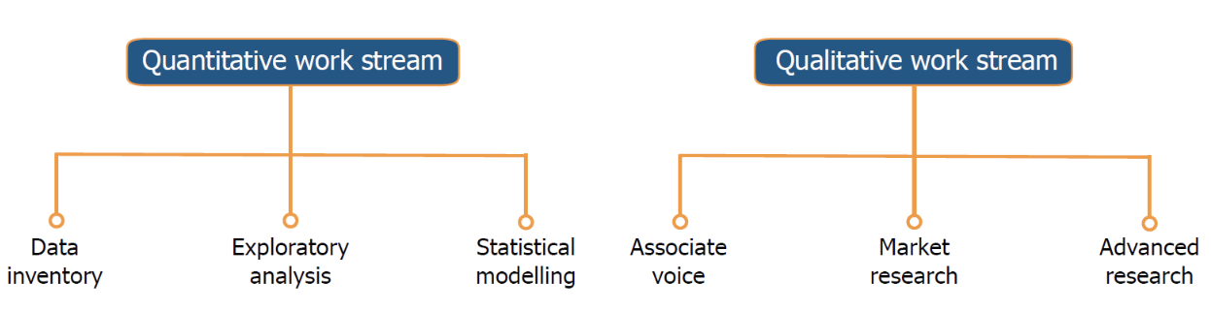

* Employee analytics is a critical tool for assessing and enhancing employee performance, according to a manager of business analytics at Walmart. Employee analytics is the process of gathering, examining, and extrapolating information on employees in order to learn more about their actions, engagement, productivity, and overall performance.

1. Finding Performance Patterns: Thanks to employee analytics, Walmart is able to spot trends and patterns in employee performance. The business may discover top performers, comprehend their habits and methods, and reproduce those practices across the firm by evaluating data such as sales figures, customer feedback, and productivity measures.
2. Walmart is able to gauge and keep track of the levels of employee engagement and satisfaction thanks to employee analytics. The business can determine the variables affecting engagement and work satisfaction by looking at data from employee surveys, performance reviews, and feedback channels.
3. Talent Acquisition and Retention: Walmart may learn more about the elements that go into effective recruitment and retention by analyzing its workforce.
4. Employee analytics are essential for detecting skill gaps and training requirements inside the firm. Walmart can pinpoint areas where employees need more training or growth opportunities by examining performance statistics and competency evaluations.
5. Performance Management and incentives: Walmart receives data-driven insights from employee analytics to create efficient performance management and incentives programs. used to find the best incentive and reward systems for motivating staff members, resulting in improved performance and increased work satisfaction.
6. Predictive analytics for employee success: Walmart can forecast future employee performance by utilizing cutting-edge analytics approaches like predictive modeling and machine learning.
7. **The Productivity, engagement, and work happiness may all be improved with the help of employee analytics.**

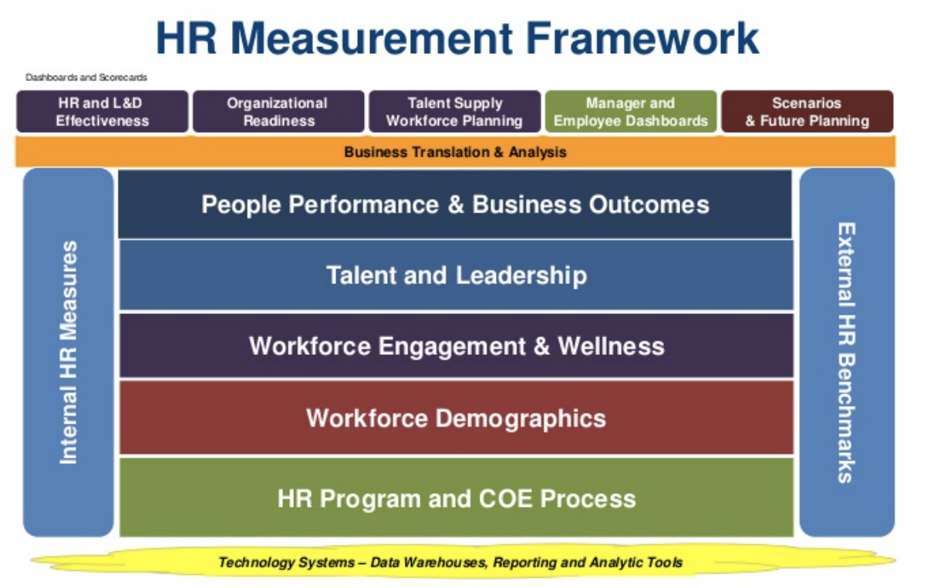

* Employee analytics may greatly improve employee productivity, engagement, and job happiness, according to a Walmart business analytics manager. An examination of how employee analytics can lead to these effects is provided below:

1. Employee analytics aids in identifying the elements that influence productivity and performance. Walmart can identify trends and productive best practices by studying data on team and individual performance, time and task management, and process efficiency.
2. Personalized Development Opportunities: Analyzing employees' skills and competencies reveals important information about their capabilities. Walmart can provide employees with individualized professional development options by reviewing performance statistics, training records, and individual preferences. This could take the form of mentorship relationships, specialized training plans, or employment rotations that fit each person's professional objectives.
3. Support for Proactive Employees: Analytics for employees can help Walmart spot early indications of disengagement or unhappiness. The organization can identify patterns suggestive of deteriorating engagement or work happiness by examining data from employee surveys, feedback systems, and performance indicators.
4. Performance Recognition and incentives: Thanks to employee analytics, Walmart is able to create efficient performance incentives and recognition schemes. The organization can create equitable and open compensation structures that are in line with the accomplishments of both individuals and teams by assessing performance data and selecting key performance indicators.
5. Team Dynamics and Communication: Employee analytics can shed light on the dynamics of teams and how they cooperate. Walmart can pinpoint places where communication or collaboration breakdowns take place by looking at data on communication channels, project collaboration, and team effectiveness.
6. Talent Allocation and Workforce Planning: Employee analytics support talent allocation and workforce planning strategically. Walmart can make wise judgments about workforce efficiency, skill development initiatives, and talent placement by looking at data on employee capabilities, performance, and career aspirations.

Note: In conclusion, using employee analytics can improve productivity, engagement, and work happiness, according to a Walmart business analytics manager. Walmart can put into practice focused tactics to enhance performance, offer individualized growth opportunities, recognize and reward accomplishments, promote collaboration, and address employee issues by assessing pertinent data and leveraging data-driven insights.

1. **The possible difficulties and moral issues related to gathering and analyzing employee data.**

* The collection and analysis of employee data may present difficulties and ethical dilemmas for a business analytics manager at Walmart. Let's talk about a few of them:

1. Data Privacy and Security: Complying with stringent data privacy and security requirements is necessary while collecting and maintaining employee data. It is crucial to make sure that employee data is shielded from misuse, illegal access, and breaches.
2. Transparency and informed consent: Walmart must make sure that staff members are fully informed about the gathering and use of personal data. It is essential to communicate openly about the goal, the sorts of data gathered, and any potential effects on personnel.
3. The accuracy and objectivity of the data are crucial for employee data analytics. However, data gathering procedures or analysis algorithms may unintentionally harbor biases. Walmart must take proactive measures to eliminate discrimination based on protected traits including gender, ethnicity, age, or handicap.
4. Employee Trust and Perception: Gathering and analyzing employee data may cause some employees to feel that they are being watched or that their privacy is being invaded.
5. Regulatory Compliance: As a business with operations across several jurisdictions, Walmart is required to abide by all applicable data protection and privacy laws, including the California Consumer Privacy Act (CCPA) in the US and the General Data Protection Regulation (GDPR) in the EU.
6. Data Governance and Retention: To guarantee that employee data is safely managed throughout its lifecycle, proper data governance procedures must be in place.
7. Empowering employees to take control of their data and allowing them to withdraw their consent is something Walmart should do. Employees ought to have the ability to see, update, or remove their personal data.

**Business analytics's upcoming trends:**

1. **The Examine new developments in business analytics with regard to trends and technologies.**

* As Certainly! Business analytics is a field that is always changing, and a number of new ideas and technology are influencing the way it is practiced. Here are a few noteworthy ones:

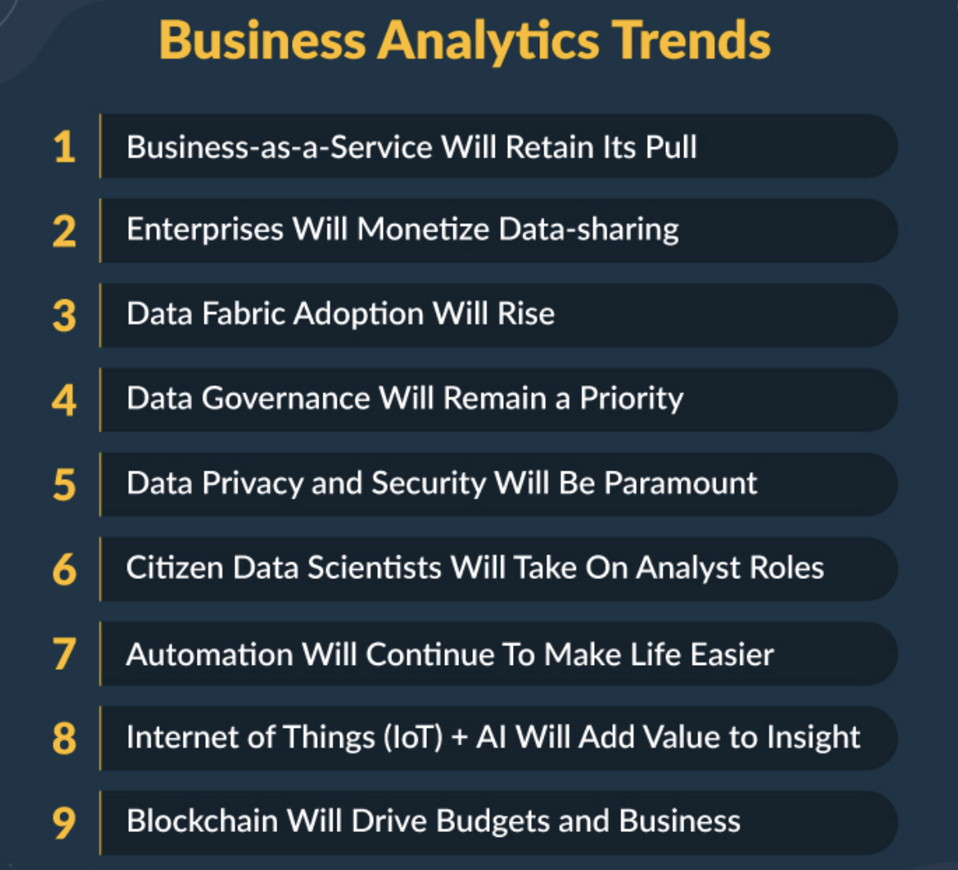

1. Data preparation, insight production, and reporting may all be automated using augmented analytics, which integrates machine learning, natural language processing, and data visualization.
2. Artificial intelligence and machine learning are rapidly being used in business analytics to analyze enormous volumes of data, find trends, provide forecasts, and streamline decision-making procedures.
3. Predictive analytics predicts future outcomes using past data and statistical models, whereas prescriptive analytics recommends the best course of action based on forecasts. These methods help businesses make data-driven decisions, streamline operations, reduce risks, and spot growth prospects.
4. Real-time and streaming analytics: These techniques let businesses analyse and examine data as it is being produced. This technology is especially beneficial for sectors like finance, telecommunications, and internet of things (IoT), where real-time insights and quick decisions are essential for operational effectiveness and competitive advantage.
5. Computers can comprehend and interpret spoken and written human language thanks to natural language processing (NLP). It has uses in text analytics, voice assistants, chatbots, and sentiment analysis.
6. Big Data Analytics: Due to the exponential growth of data, big data analytics techniques and technologies are crucial for gaining understanding from sizable and complicated datasets.
7. Cloud-based analytics: By offering scalable and affordable infrastructure, cloud computing has completely changed the analytics industry. Organizations can store, process, and analyze data in the cloud using cloud-based analytics solutions, which also offer flexibility, accessibility, and collaboration capabilities.
8. Data Governance and Ethics: As businesses deal with massive amounts of data, it's become more crucial than ever to ensure data security and ethical use.
9. Explainable AI: Transparency and interpretability are becoming more and more important as AI and ML models become more complicated. Explainable AI strategies are designed to give enterprises insights into how AI models make decisions, enabling them to comprehend and justify their outputs, increasing trust and regulatory compliance.

Note: The way businesses use data to acquire insights, make wise decisions, and spur innovation and growth is changing as a result of these new business analytics trends and technologies. Businesses can maintain their competitiveness in an environment that is becoming more data-driven by keeping up with these changes.

1. **The possible effects of innovations like artificial intelligence, machine learning, or big data analytics on employee, market, and customer analytics (including pricing tactics).**

* Environment Customer analytics, market analytics (price strategies), and employee analytics might all be profoundly impacted by developments in artificial intelligence, machine learning, and big data analytics. Let's look at the possible effects of each one:

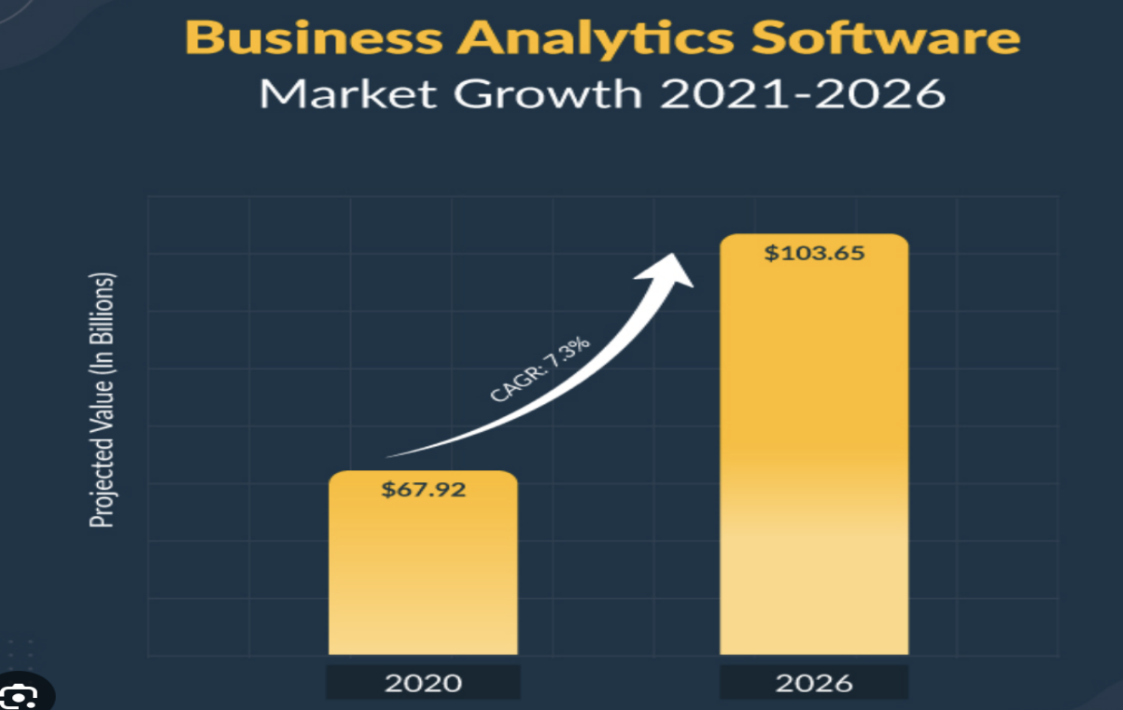

* Customer Analytics:
* Personalized Customer Experiences: Artificial intelligence (AI) and machine learning are capable of analyzing vast amounts of customer data to find trends, preferences, and behaviors.
* consumer Segmentation: Based on a variety of characteristics and behaviors, machine learning algorithms may pinpoint specific consumer segments. This makes it possible for firms to develop customized marketing plans and to maximize their efforts to acquire and keep customers.
* Sentiment analysis: Natural language processing techniques allow for the study of sentiment in online reviews, comments, and social media posts. This offers useful insights on client preferences, opinions, and attitudes, enabling businesses to address issues.
* Dynamic Pricing: Market Analytics (Pricing Strategies)
* Real-time pricing strategy optimization can be achieved by combining big data analytics with AI and machine learning. Businesses have the ability to dynamically modify prices to maximize revenue and profit margins by studying market trends, rival prices, customer demand, and other pertinent data.
* Price optimization: To identify the best prices for goods and services, advanced analytics tools can examine past sales data and market conditions. This aids companies in setting prices that are attractive to customers, lucrative, and competitive.
* Demand Forecasting: Using previous data, seasonality, promotions, and outside variables, machine learning algorithms can forecast client demand. The optimization of inventory management, production planning, and price decisions is aided by accurate demand forecasting.
* Analytics for Employees:
* Performance Assessment and Development: AI and machine learning algorithms can examine employee performance data, feedback, and training records to reveal individual strengths, weaknesses, and development prospects. Due to the ability to customize training programs, mentorship programs, and career development plans, firms may increase employee engagement and performance.
* Employee Retention and Attrition Prediction: Predictive models can find signs of potential attrition by examining employee data, including as performance, satisfaction surveys, and demographic characteristics.
* Workforce planning and optimization: Big data analytics can shed light on the demographics, competencies, and future talent requirements of the workforce. By detecting skill shortages and maximizing talent allocation, this aids in strategic workforce planning and boosts organizational effectiveness.

1. **The advantages and difficulties these upcoming trends provide for businesses walmart.**

* Big data analytics, artificial intelligence, and machine learning bring potential as well as obstacles for businesses like Walmart. Now let's assess them:
* Opportunities:
* Personalized recommendations, targeted marketing initiatives, and frictionless shopping experiences are just a few of the improvements Walmart can make to its customers' experiences that will increase their pleasure and loyalty.
* Improved Operational Efficiency: Walmart can optimize inventory management, supply chain procedures, and operational efficiency by utilizing data analytics, which will lead to cost savings and increased productivity.
* Making decisions based on data: AI and machine learning algorithms can analyze massive amounts of data to produce useful insights, enabling Walmart to make decisions based on data in areas like pricing, product selection, and demand forecasts.
* Employee Engagement and Performance: Walmart can use advanced analytics to better understand employee engagement, training requirements, and performance. This makes it possible to create customized development programs, pro-active support, and efficient staff planning, all of which increase employee productivity and happiness.
* Competitive Advantage: By embracing these technologies, Walmart is able to keep one step ahead of rivals by utilizing data to spur innovation, enhance workflows, and provide better customer experiences.
* Challenges:
* Data security and privacy: The growing reliance on consumer and employee data presents difficulties for maintaining data security, privacy, and regulatory compliance. Walmart must implement effective data protection procedures and uphold customer confidence in how their personal information is handled.
* Talent and Skill Gap: A skilled workforce capable of deciphering and analyzing complicated data is necessary for the successful adoption of advanced analytics. Walmart must make an investment in finding, developing, and keeping employees skilled in data analytics and machine learning.
* Scalability and Integration: Combining many technologies, systems, and data sources can be challenging. Walmart must provide a scalable and adaptable architecture and guarantee interoperability between various analytics systems and technologies.
* Walmart needs to take ethical issues including algorithmic biases, data usage, and responsible AI deployment into account. Fairness, accountability, and transparency must all be ensured in the decision-making process.
* Change management: Implementing these technologies calls for a culture shift toward a data-driven attitude as well as organizational reforms. To guarantee that analytics capabilities are effectively adopted and used throughout the firm, change management initiatives are required.

Note: In conclusion, Walmart has a lot of opportunities to improve customer experience, increase operational efficiency, make data-driven decisions, increase employee performance and engagement, and gain a competitive edge thanks to the future trends of artificial intelligence, machine learning, and big data analytics. To properly use these technologies, it is necessary to handle issues with data privacy, talent recruiting, integration, ethics, and change management.

# Conclusion

In conclusion, customer, market, and staff analytics are all essential tools for Walmart to comprehend and enhance a variety of business processes. Walmart is able to generate focused marketing campaigns, individualized customer experiences, and cutting-edge products by using customer analytics to gather deep insights into consumer behavior, preferences, and needs. By examining market dynamics, consumer trends, and competitor strategies, market analytics helps businesses develop effective pricing strategies. It enables Walmart to adjust prices in accordance with costs, value, and market circumstances. Understanding and improving employee performance, productivity, engagement, and work satisfaction depend heavily on employee analytics. It gives Walmart the ability to spot performance trends, offer specialized learning opportunities, put in place performance rewards and incentives, and tactically plan staff allocation.

While there are many advantages to these analytics tools, there are also difficulties to take into account. These include managing organizational transformation, investing in infrastructure and technology, solving the skills gap in data analysis, safeguarding privacy and data security, and guaranteeing data integrity and quality. While navigating these difficulties, Walmart must uphold moral principles and observe legal requirements.

# **Reference & Bibliography**

1. 'What is Customer Analytics?' Emeritus (n.d.) Visit https://emeritus.org/in/learn/what-is-customer-analytics/ for more information. (Retrieved: June 5, 2023).
2. 'What is Customer Analytics and Why is it Important?' is the topic of Analytics Vidhya's 2021 lecture. Available at: https://blog.analyticsvidhya.com/2021/12/what-is-customer-analytics-and-why-is-it-important/ (Retrieved: June 5, 2023).
3. 'How Big Data Analysis Helped Increase Walmart's Sales Turnover,' ProjectPro (n.d.), https://www.projectpro.io/article/how-big-data-analysis-helped-increase-walmarts-sales-turnover/109 (Retrieved: June 5, 2023).
4. 'CASE STUDY - WALMART: Scripting Success Through Customer Analytics' by T. H. Davenport and J. Glaser (2013). Available at: 256926820_CASE_STUDY_-_WALMART_SCRIPTING_SUCCESS_THROUGH_CUSTOMER_ANALYTICS on ResearchGate. (Retrieved: June 5, 2023).
5. 'Walmart SWOT Analysis' Business Model Analyst (n.d.), online at https://businessmodelanalyst.com/walmart-swot-analysis/ (Retrieved: June 5, 2023).
6. 'Market Research' by Radius Insights, n.d. Available at: https://radiusinsights.com/radius-lp1/?utm_source=google&utm_media=cpc&utm_campaign=generic_germany_phrase_desktop&utm_term=market%20research%20in&gclid=Cj0KCQjwj_ajBh (Retrieved: June 5, 2023).
7. Walmart Inc. Marketing Research for Consumer Perception. Business Essay. [Online]. Available from: https://business-essay.com/walmart-inc-marketing-research-for-consumer-perception/. (Retrieved: June 5, 2023).
8. 'Walmart Ecosystem' (Algopix, n.d.). Available at: https://algopix.com/ecosystem/walmart (Retrieved: June 5, 2023).
9. 'What Walmart Learned from HR Analytics' by HRD Connect (2016) The article is accessible at: https://www.hrdconnect.com/2016/04/27/what-walmart-learned-from-hr-analytics (Retrieved: June 5, 2023).
10. Why does Walmart prioritize HR analytics for the future workforce?, Quora (n.d.). (Accessed: 5 June 2023) Available at: https://www.quora.com/Why-does-Walmart-focus-on-HR-analytics-for-the-future-workforce.
11. 'Gartner Report: Top Trends in Data and Analytics for 2023', Qlik (n.d.). Located at: https://www.qlik.com/us/lp/sem/Gartner-report-top-trends-in-data-and-analytics-for-2023?utm_team=DIG&utm_subtype=cpc_nb&ppc_id=hGV31UKU&kw=%2Bbusiness%20%2Band%20%2Banalytics&utm_content=hGV31UKU_pcrid_658714929976_pmt_b_pkw_%2Bbusiness%20%2Band%20%2Banalytics_pdv_c_msl